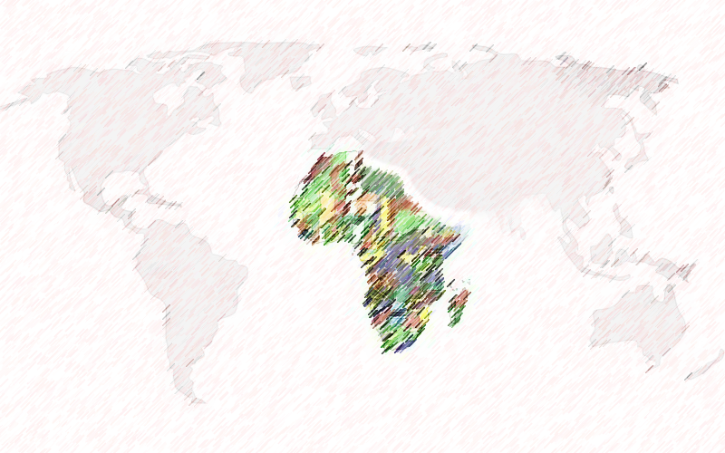

**Moderator and Presenter: Professor Joseph Mensah Department of Geography, York University**

**Panelist:**

**Associate Professor Silvia Bawa**

**Department of Sociology**

**York University**

**Reverend Father Korsah**

**Reverend Atuahene**

**Reverend O.B Agyeman**

**Nana Anane**

**Mc. Douglas**

**Mr. Louis March**

**Mr. Yaw Akenten,**

**Mr. Michael Danquah**

**Dr. David Firang,**

**Ms. Evelyn Kissi**

**This community conversation will explore the role of race and racial discrimination in the lives of Black continental Africans in Canada, with emphasis on Ghanaians, and examine how the cultural attributes and the socio-economic status of these immigrants have changed as a result of being in Canada. The specific topics will include:**

* **Youth Development**
* **Black Youth Involvement in Criminal Justice System**
* **Culture and Identity**
* **Mental Illness**
* **Immigrant Story: Successes and Pitfalls**
* **Issues of Cultural Clashes and Fitting In: Parents and Canadian Born Africans**

**Join the conversation**…

**Date:** Sunday, October 28, 2018

**Location:** Ghana Presbyterian Church

51 High Meadow Place, North York

**Time:** 4:00 pm-7:00 pm

**Everyone is welcome!**

**Register:** [**Here**](http://lapsexternal.apps01.yorku.ca/machform/view.php?id=46144) **Email:** [**gce@yorku.ca**](mailto:gce@yorku.ca)

**Community Conversation Series:**

**Black Continental Africans in Canada: Black and Black African Diaspora Relation**

**Hosted and Sponsored by York University and Ghanaian Canadian Association of Ontario (GCAO)**